**MINI BLOCKS EXHIBITION APP**

This application will allow you to:

1. Create a user account
   1. You will need to enter
      1. First name
      2. Last name
      3. Email
      4. Password
   2. You will have a ‘login’ button
   3. You will have a ‘cancel’ button
2. Login
3. On the home page you will be presented with 2 options
   1. Items
      1. CREATE: Create and Item (you will have to enter the following)
         1. Item ID will be automatically added by DB
         2. Name
         3. Age Level
         4. Difficulty Level
         5. Number Of Pieces
         6. Date item was built
         7. Photo
         8. Comments
      2. READ: Sort through the items
         1. It will have a 'choose item' field
            1. Enter the name of the item we are looking for, or
            2. Dropdown list
         2. It will return the item name, a photo and no of pieces
      3. UPDATE: Update the records
         1. Dropdown list
         2. ?????????????
      4. DELETE: Delete any items
         1. Dropdown list
         2. Delete button
   2. Exhibitions
      1. CRUD (Can’t think of a name at present)
         1. Create a Hall (where you can see the items created)
            1. ID
            2. Name
            3. Description
            4. ItemsList
            5. Photos
      2. HALLS
         1. Coose what Hall Exhibition you want to see
            1. dropdown list with Halls' names
            2. (Wish list) if chosen a Hall, it will show the items for the Exhibition and dates and locations
         2. Dates
            1. dropdown list with the dates available
            2. (Wish list) it will show all Halls and locations
         3. Locations
            1. dropdown list with locations available
            2. (Wish list) it will show all Halls and dates

MIND MAPPING

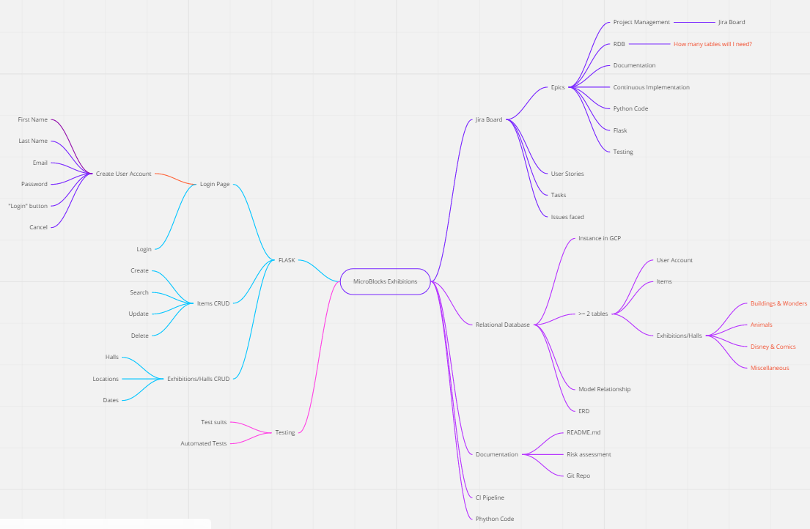

**THOUGHTS**

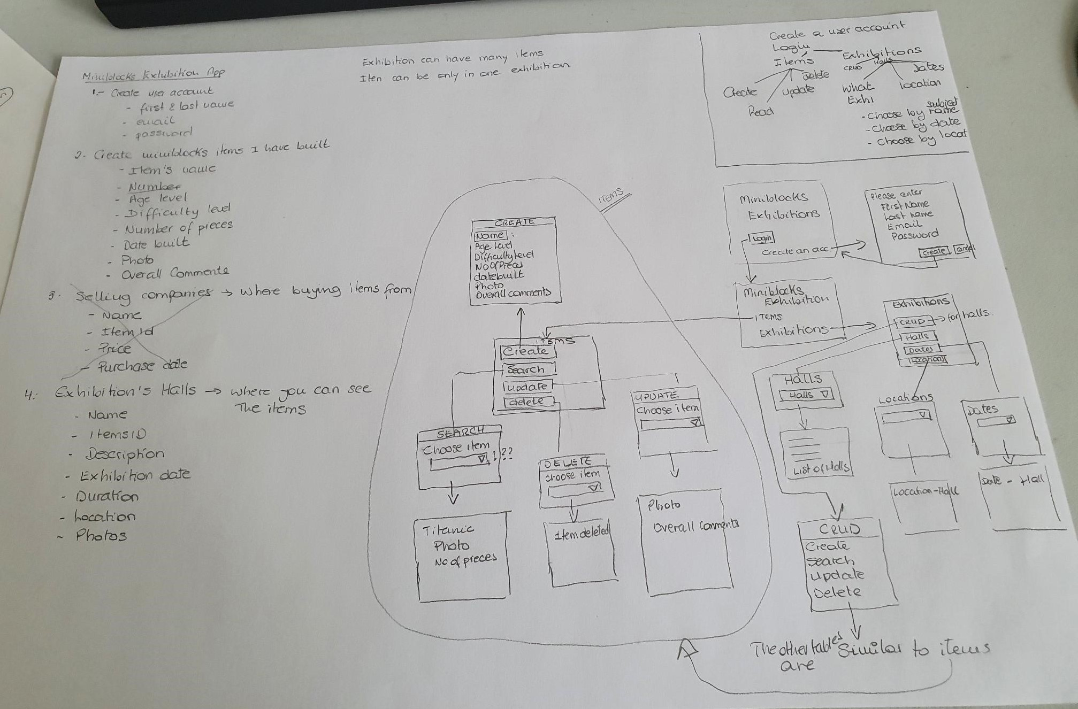

**ERD**

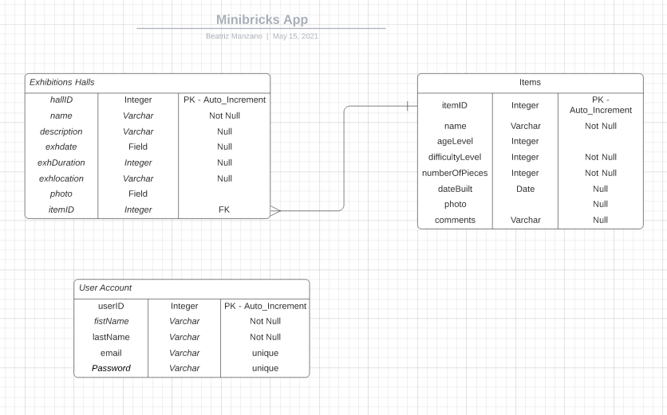

As shown in the ERD, the app models a one-to-many relationship between the Items table and the Exhibitions Table, meaning an item can only be part of one exhibition but an exhibition can have many items

**CI PIPELINE**

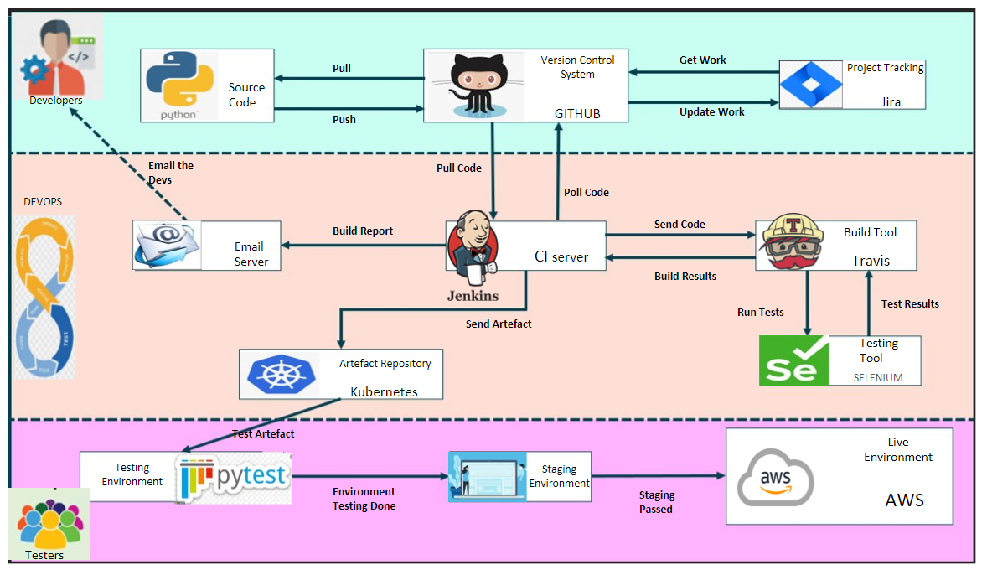

**TABLES**

* Companies I buy the items from
  + ID --> PH
  + Name
  + ItemID --> FK
  + Price
  + PurchaseDate
* Items
  + ID --> PK
  + Name
  + Number
  + AgeLevel
  + DifficultyLevel
  + NumberOfPieces
  + DateBuilt
  + Photo
  + OverallComments
* Exhibition Locations
  + ID
  + LocationName
  + Address
  + Town
  + PostCode
  + ExhibitionDate
  + Duration
* Exhibitions Halls (where you can see the items created)
  + ID
  + Name
  + Description
  + ItemsList
  + Photos

WEB PAGES

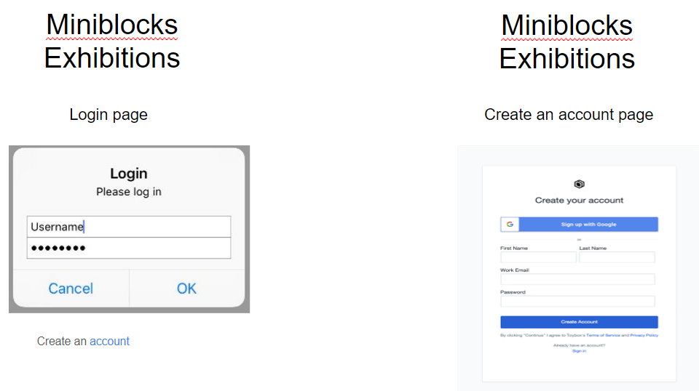

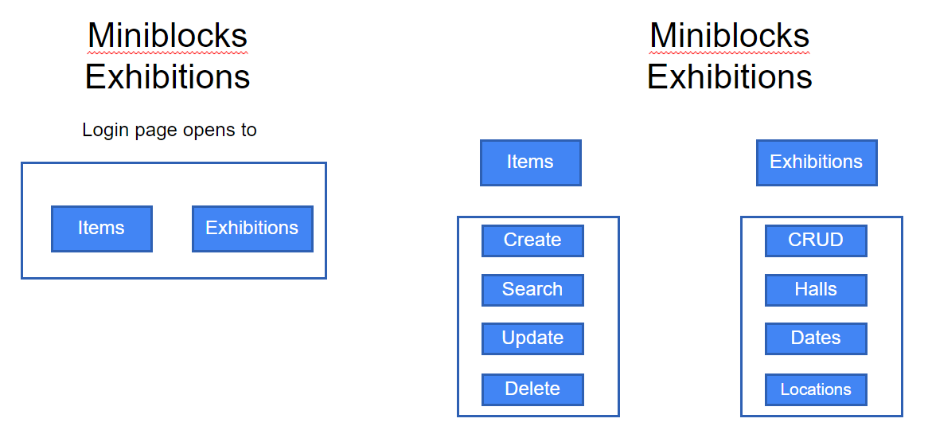

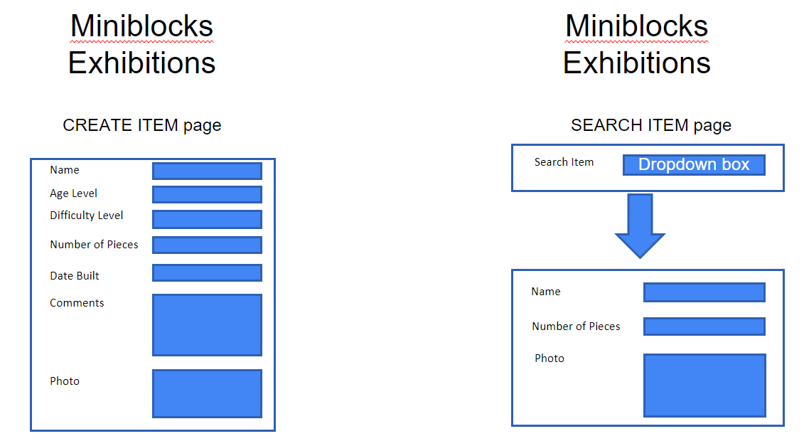

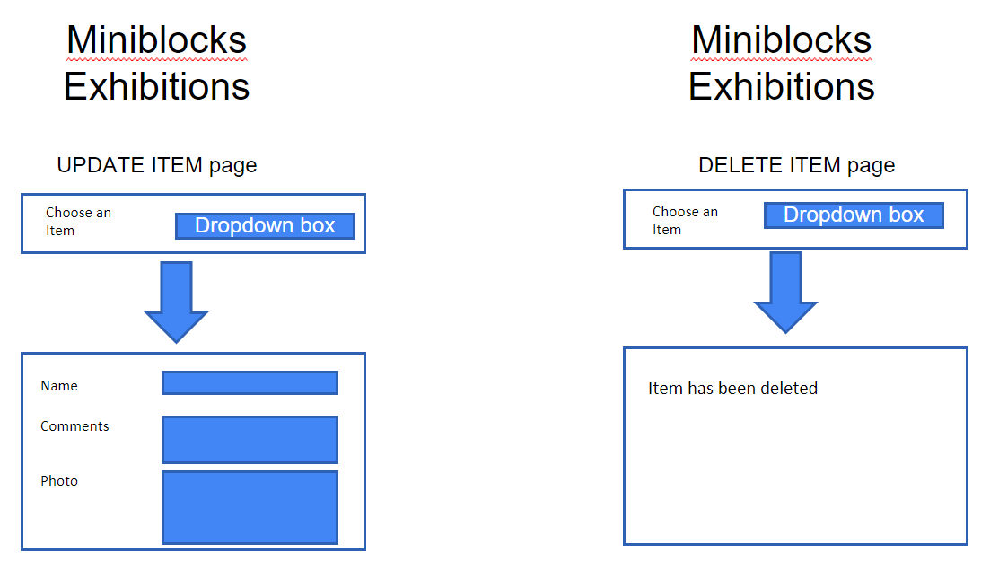

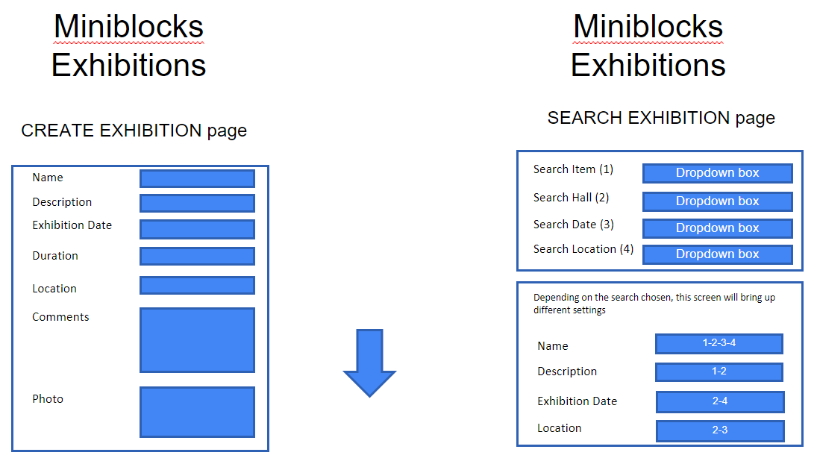

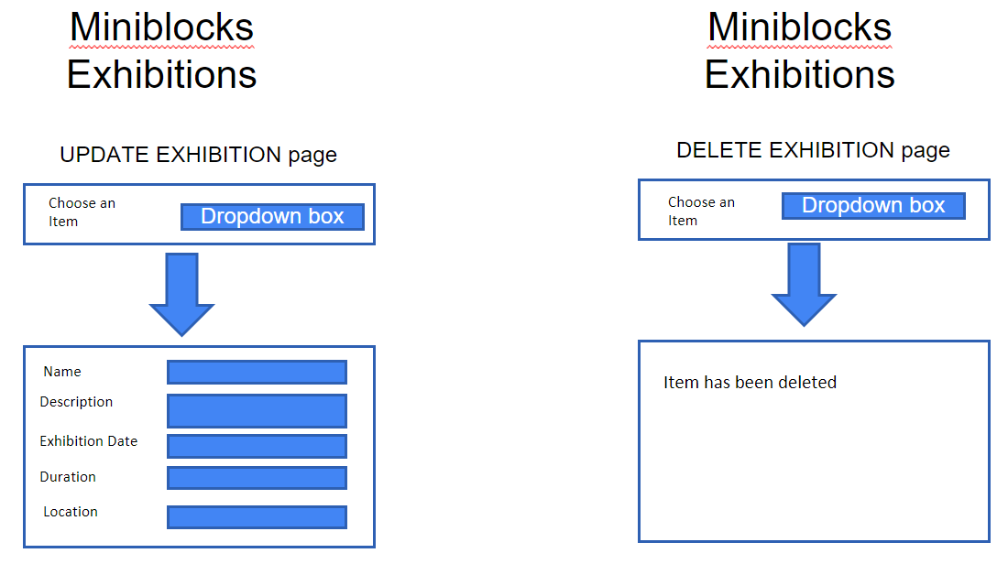

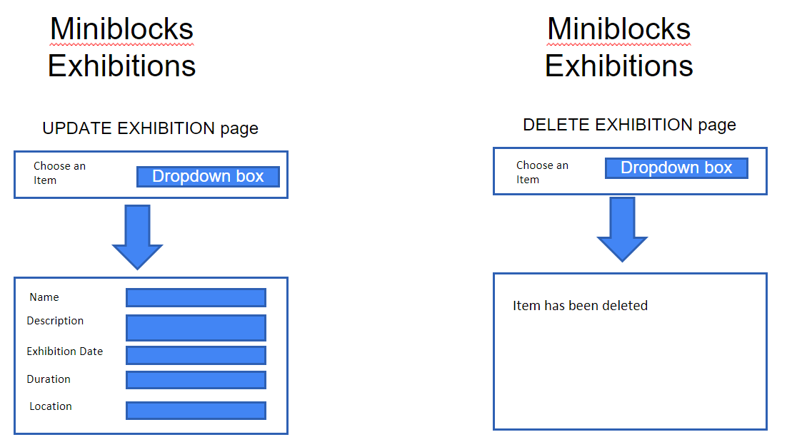

***(( Create new User (\**** *Required field)*

1. *First Name \**
2. *Last Name \**
3. *Email Address \**
4. *Password \**
5. *Create button*
6. *Cancel button*

***Sign in page***

1. *Email Address \**
2. *Password \**
3. *Login button*

***New Item***

1. *Name of the item*
2. *Number*
3. *AgeLevel*
4. *DifficultyLevel*
5. *NumberOfPieces*
6. *DateBuilt*
7. *Photo*
8. *OverallComments*
9. *Save & Close Button*
10. *Cancel Button ))*